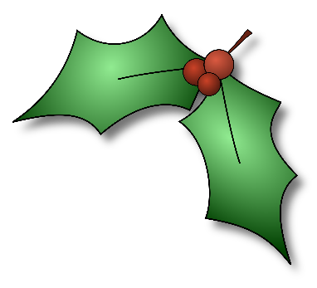
Holiday Minute to Win It Games

The options for using these games are limitless. You can set these games up randomly around the party area and either play for a set time period or just as people mingle. If you wish, you can ask different people to run each game and hand out prizes to those who win the challenge. You can also turn this into a team challenge by forming teams, setting up stations around the room, and requiring everyone from each team to participate at least once as the teams rotate from station to station.
We’ve also provided an audio file that counts down the minute with music that you can use at each game or station.
1. Candy Cane Pick Up – Place a pile of candy canes on a table and provide a tray or basket for each player. Give each player a candy cane to put in his mouth with the hook end down. The player must use the candy cane hook to pick up the other candy canes and move them to the basket. The player with the most candy canes in their basket after one minute wins! Each participant gets to keep their candy cane.
2. Sugar Cookie Face – Provide cookies for each player. Players must place one cookie on their forehead and use their face muscles to move it into their mouth. The player who has gotten the most cookies in their mouth after one minute is the winner!
3. Gingerbread High Rise – Provide graham crackers, icing, and a paper plate for each player. Players have one minute to build a tower using the graham crackers and icing. The player with the tallest tower after one minute wins!
4. Snowball Fight – Provide white paper for each player or team. Place a dividing line in the middle of the room. Players or teams will need to wad up the white paper and have a snowball fight. The player or team who has the least number of “snowballs” on their side after one minute is the winner!
5. Human Christmas Tree – Provide garland and/or toilet paper for each player or team. Choose one person to be the human Christmas tree. The player or team has one minute to wrap the “tree” in garland and toilet paper. The team who best covers the “tree,” having the least amount of the covered person visible after one minute, wins!
6. Marshmallow Toss – Provide a wreath, a bag of marshmallows, and a bucket for each player. Have one person hold the wreath to their side and place the bucket behind the wreath. Players will have one minute to throw marshmallows through the wreath into the bucket. The player with the most marshmallows in the bucket after one minute is the winner!!

