Here are your printouts and posters for the week. Again, we’ve left them basic because it’s better if they look like they came from you, not pre-produced. But feel free to improve them, print out multiple copies, use colored paper, etc… And these definitely don’t have to be your only decorations.

The first section is the daily posters.
The second section is the creative compliments.
The third section is the new mission for co-worker appreciation day.

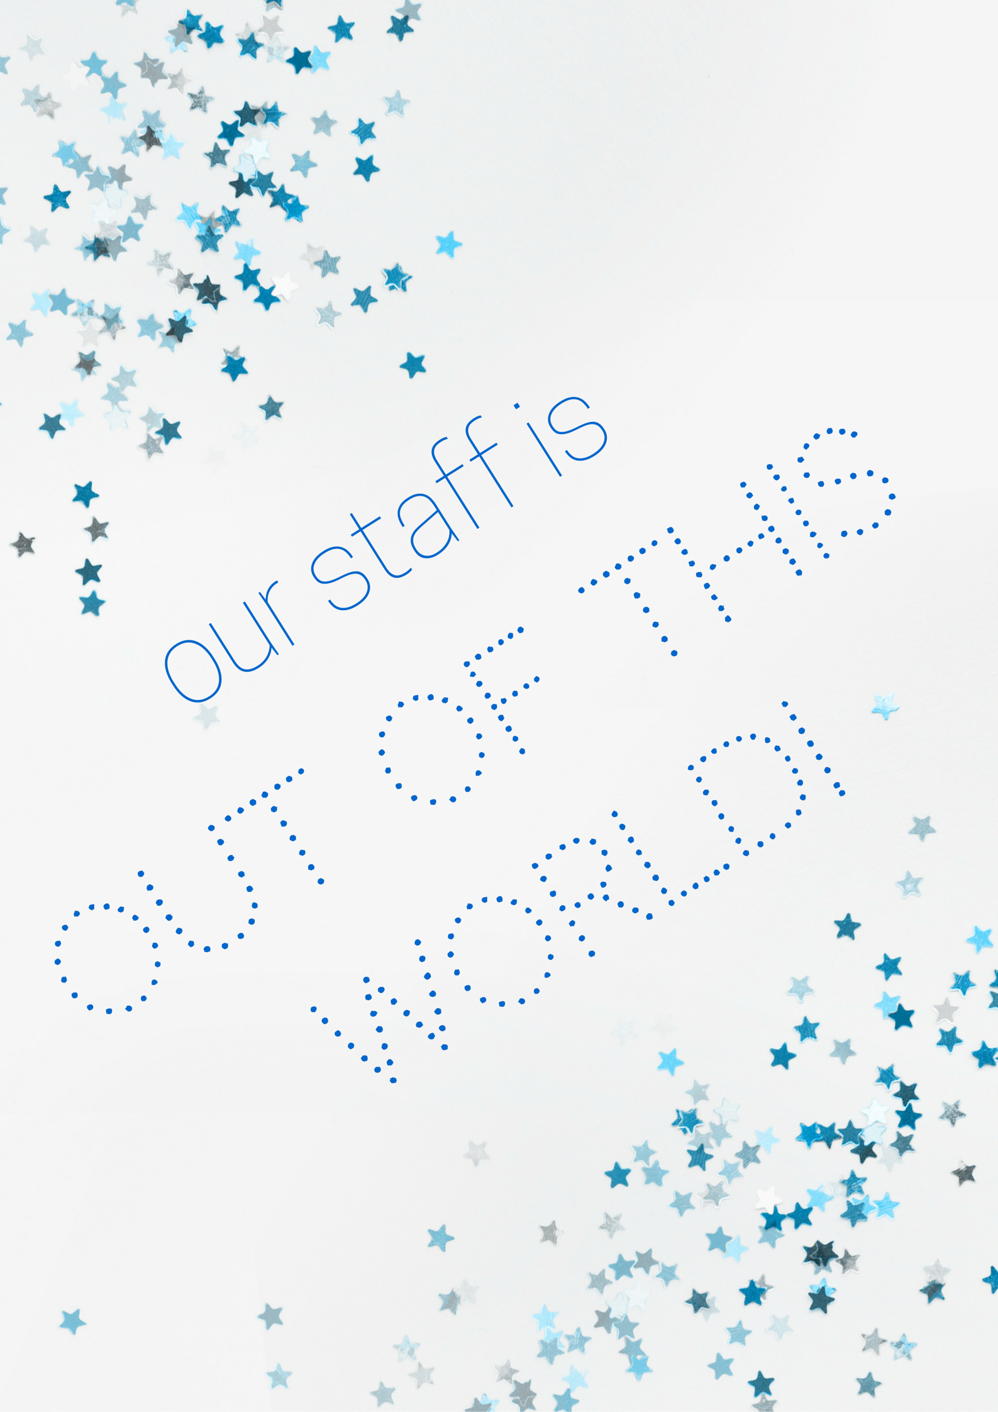
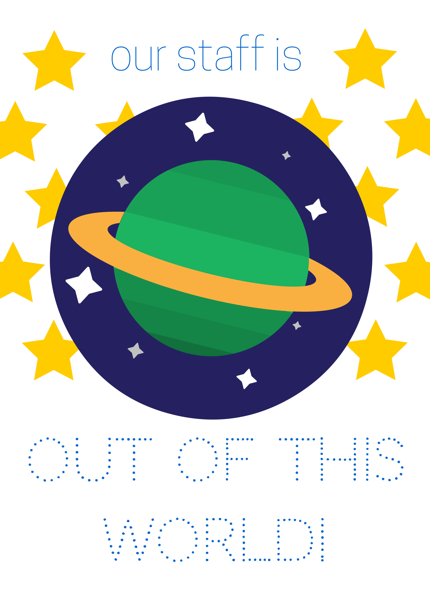
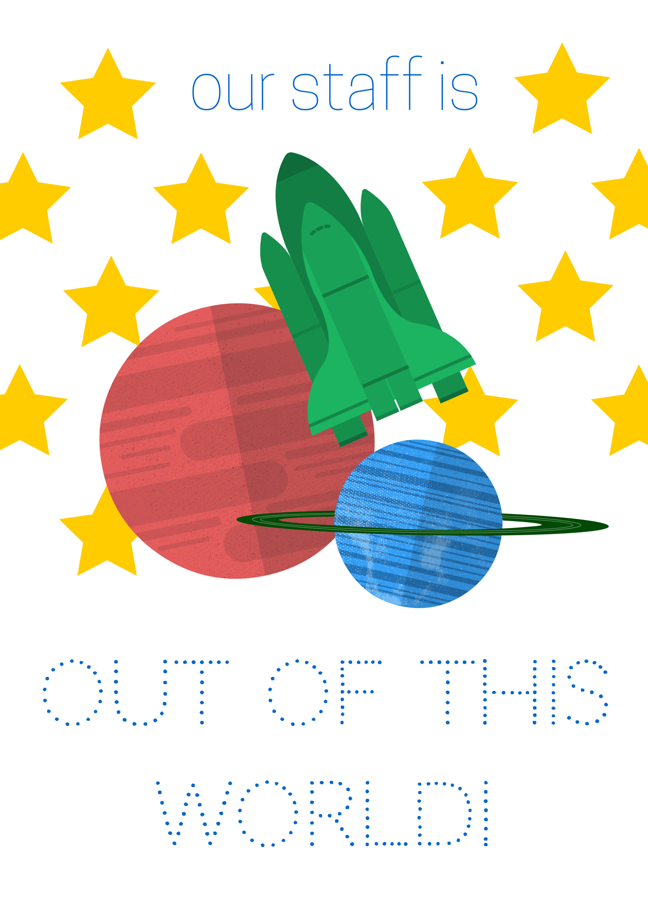
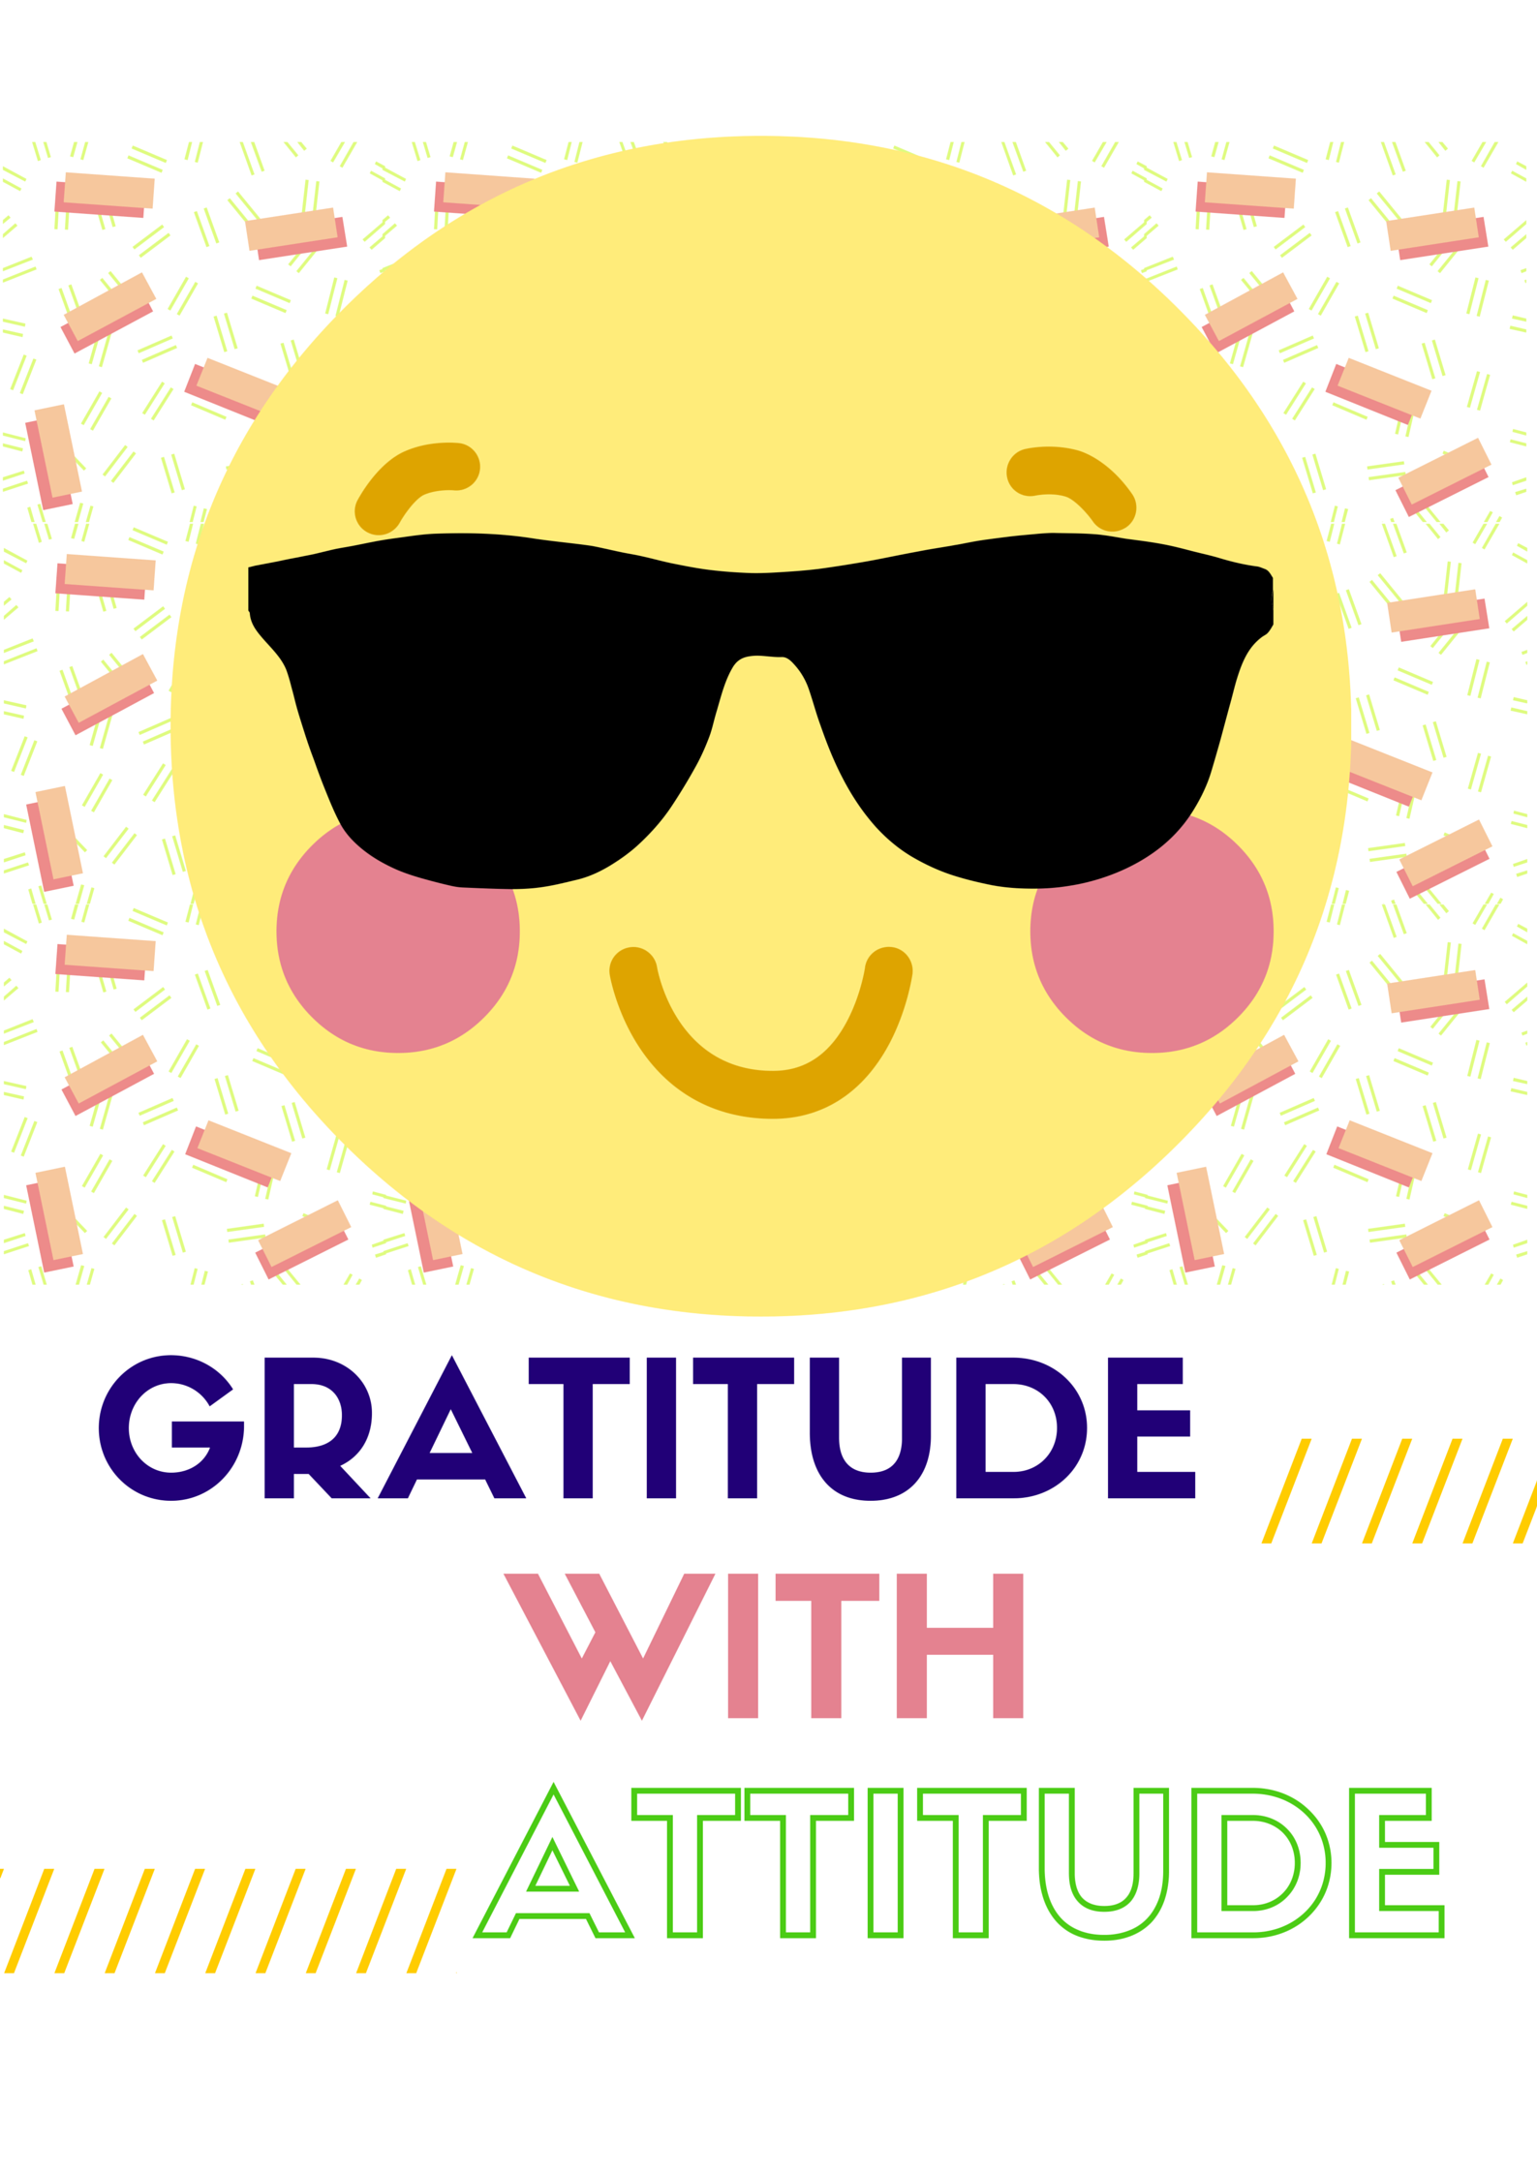
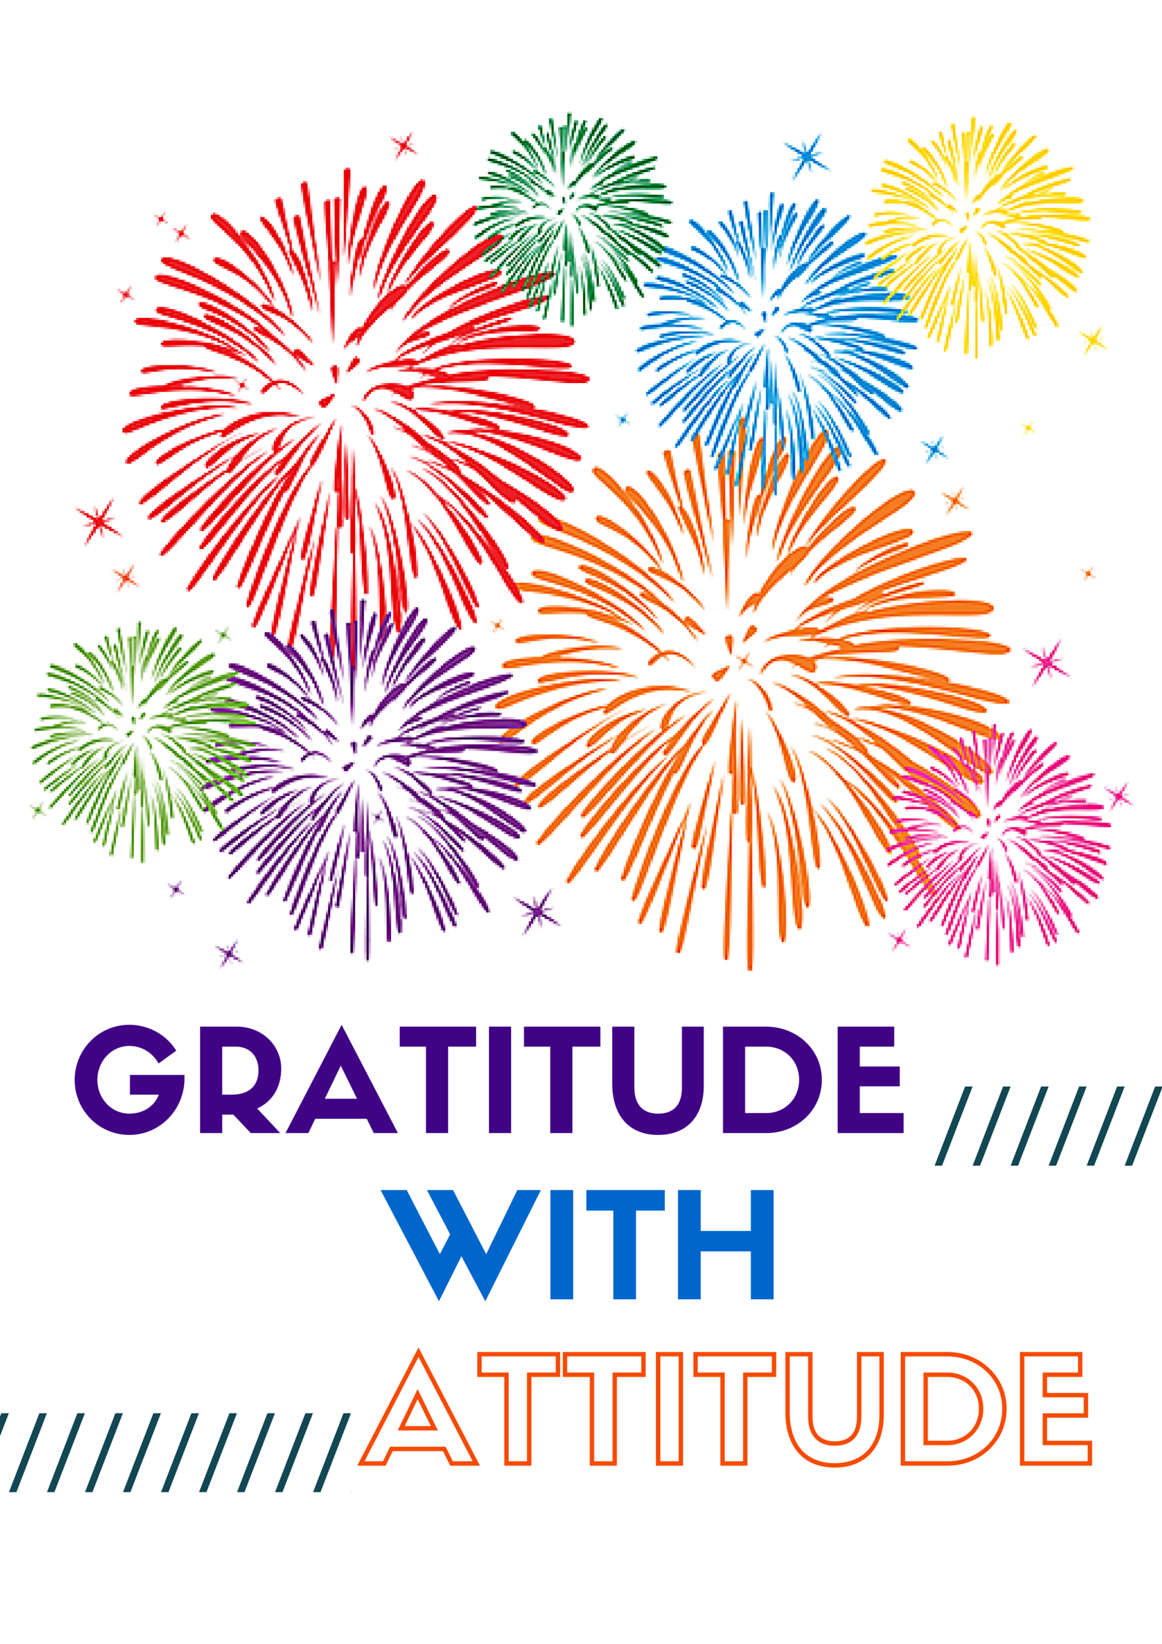
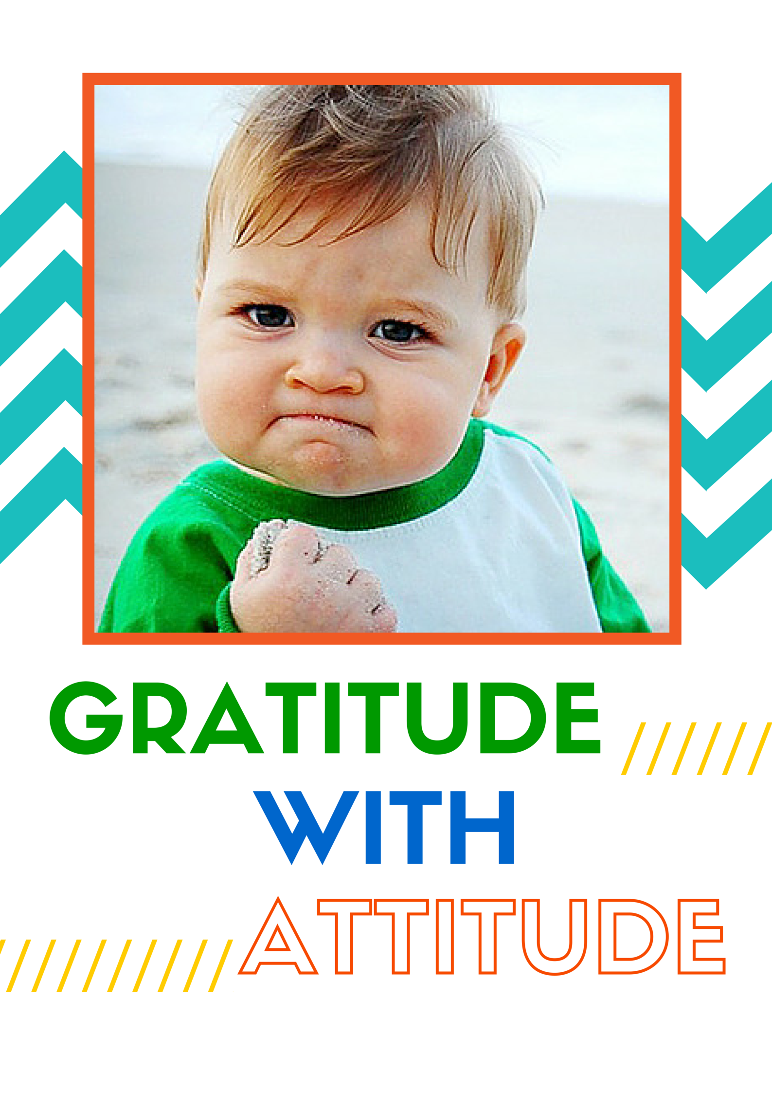
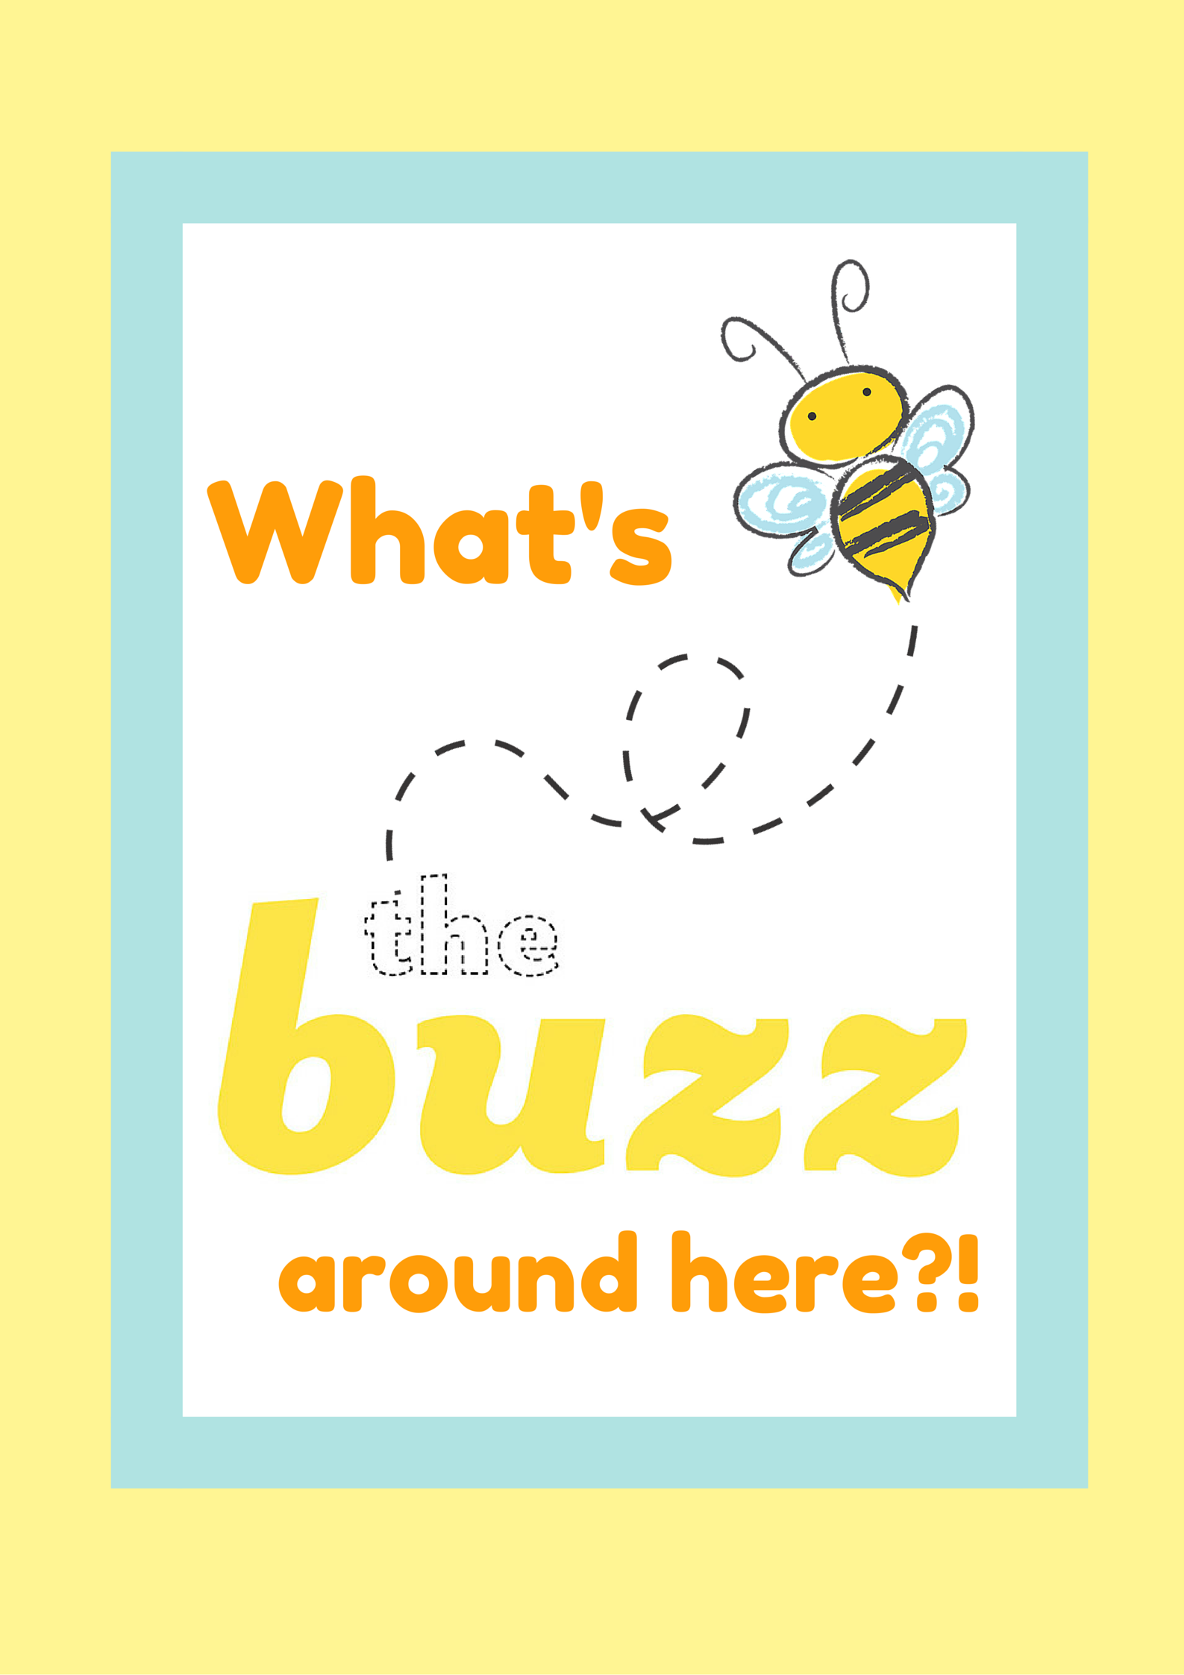
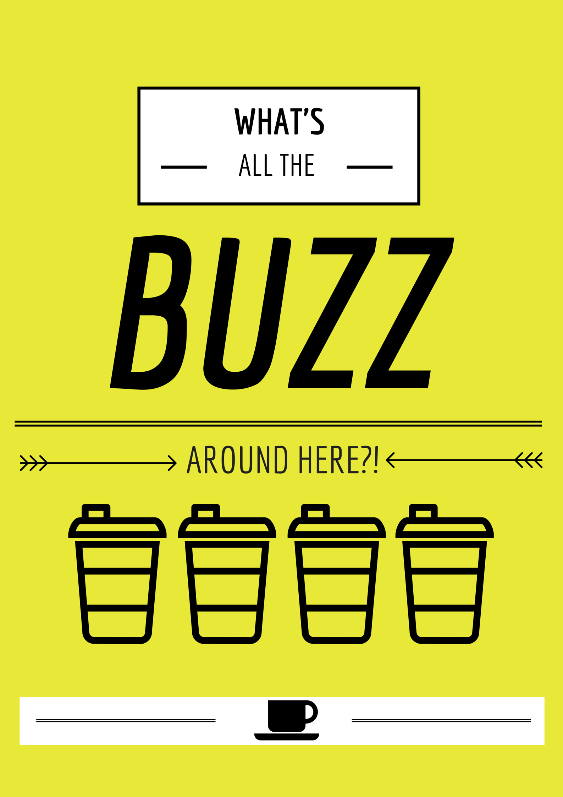
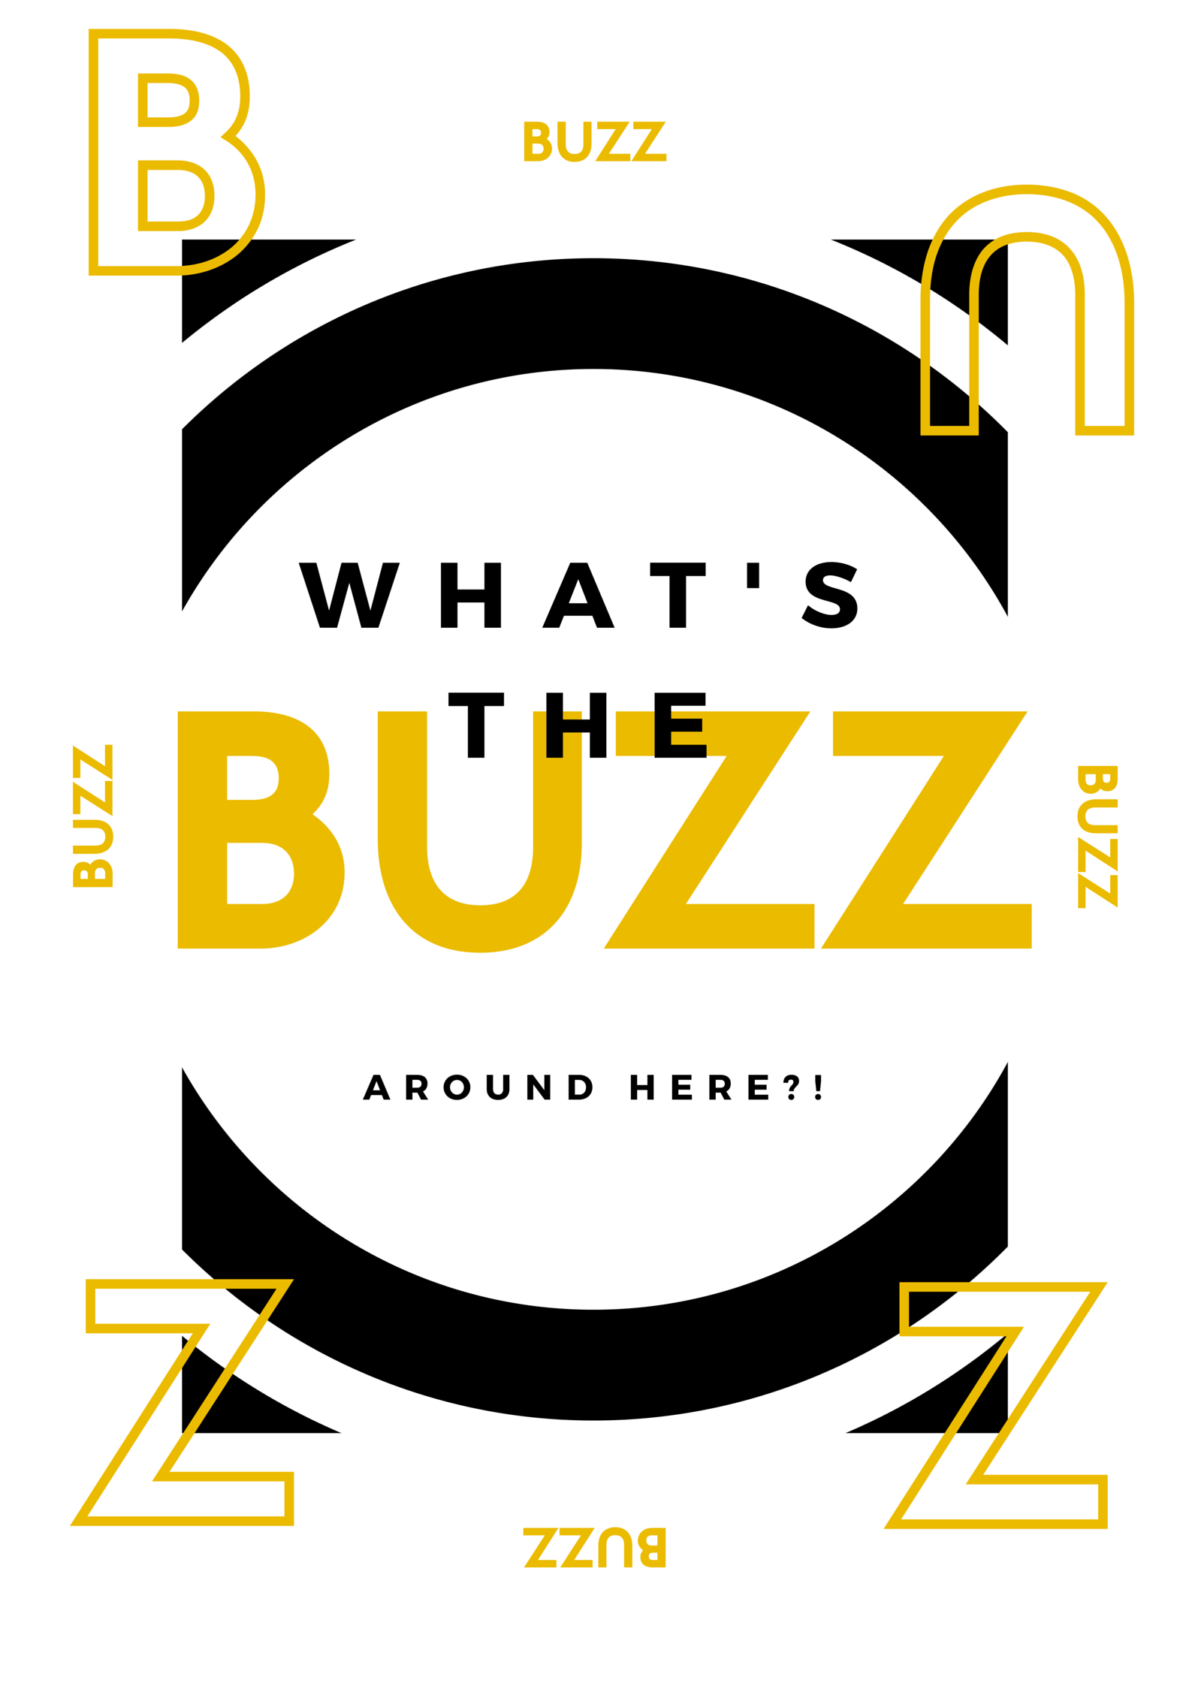
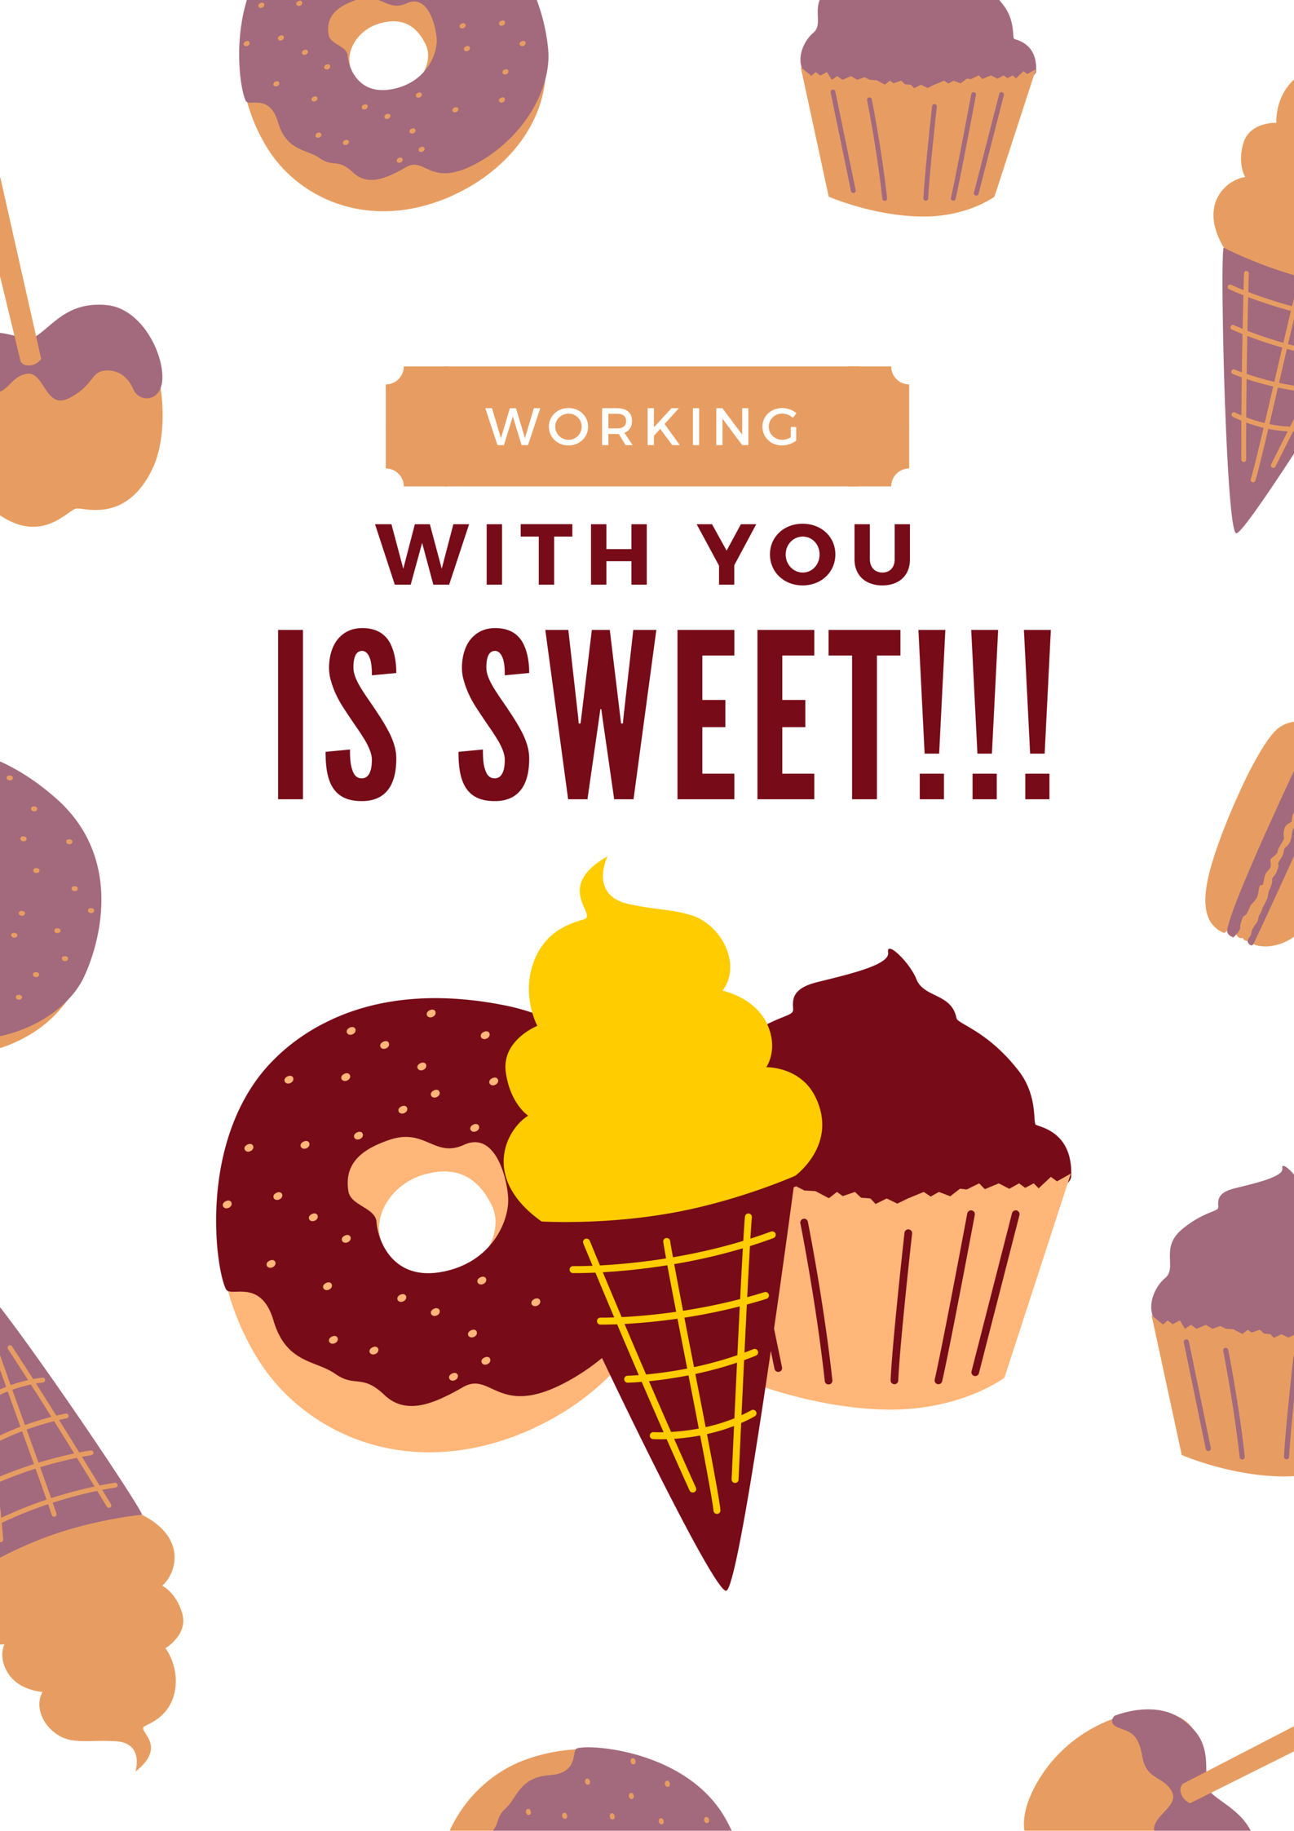
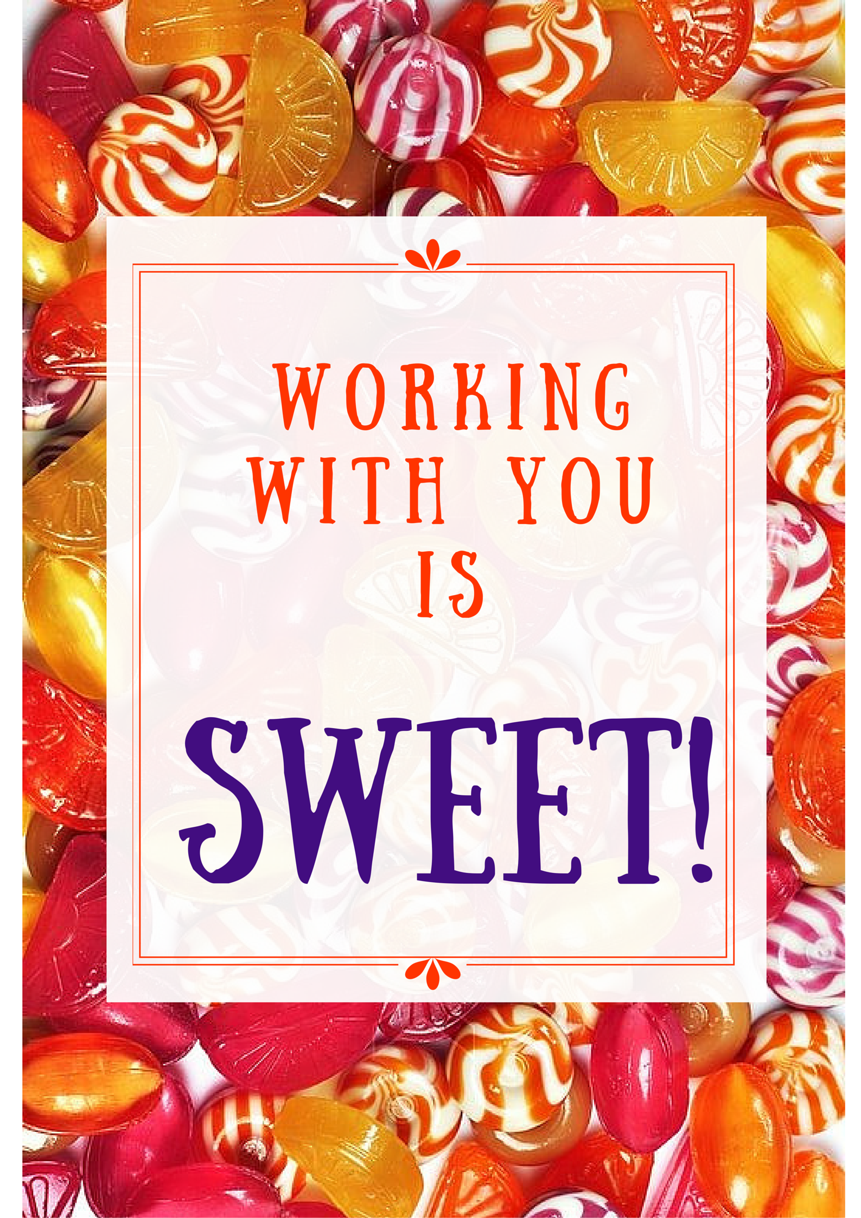
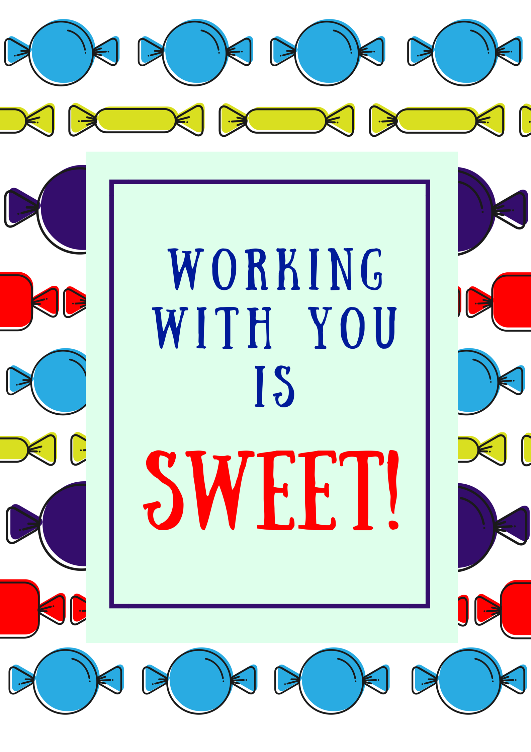

I often don't know what I'm doing, but when you're around, I'm at least having fun.

Being normal is overrated. I'd much rather be weird with you.

You may not be perfect, but your weirdness matches mine and that's close enough.

If ninjas captured you, I would spend all of my free time training to be a stellar ninja. Which might take some time, since I am very far from being that, but I want you to know that I would eventually save you.

Every day without you is like a day without my phone: I just don't know what to do with myself.

Sometimes I just need to throw a mini tantrum. And you know that, and allow me to complete it, and I appreciate that. You’re a good friend.

I like that if you don't have anything nice to say, you will go ahead and say it anyway. You play by your own rules and I admire that.

You're cool because you don't judge me when I get excited about something lame.

I honestly think you can do anything you put your mind to. But I know what kind of thoughts you have, so maybe hold off on that for now.

I like having you around because my weirdness doesn't look so weird when you're doing it too.

Every day is just blah when I don't see you.

In a world of lady bugs, you are a tiger. Yeah, that’s right. You are that much better than everyone else.

If someone invented a time machine that could only be used by cool people, I bet you'd be able to travel back in time, no problem.

I thought I was normal, until I met you. Then I realized we're both pretty weird. And I like that about us.

I really like that you understand my sarcasm because it's an advanced form and not everyone gets it.

If I had 100 wishes, 'spend more time with you' would be around wish number 5.

I honestly think you can do anything you put your mind to. But I know what kind of thoughts you have, so maybe hold off on that for now.

You are one of the few people who understand the pure joy in doing absolutely nothing.

In a world of lady bugs, you are a tiger. Yeah, that’s right. You are that much better than everyone else.

Every day is just blah when I don't see you.

If I had the money, whenever you were sad, I would hire a super funky jazz band to play behind you when you walked. And if that didn't cheer you up, at least you'd look really cool.

Sometimes it feels like you're the only person who truly understands my random shouting. And I'm so thankful for that because all of those weird noises mean something.

Your patience during my time of venting frustration is greatly appreciated.

I don't like when your opinion doesn't match up with mine. And that's not because I'm selfish. It's because you're my best friend and I want you to like nice things.

Some people are all, 'You're the cheese to our macaroni.' But our bond is much greater than noodles. You're more like the cheese to our macaroni, pizza, crackers, nachos, and burgers.

Sometimes I feel like you're the only person who truly understands my irrational excitement over certain things.

They say a dog is a man's best friend, but you're my best friend and you're way better than a dog. Unless there is a breed of pancake-making dogs out there that I have somehow missed. You know, pet the dog, get a pancake. Yeah, that transaction might beat you.

It'd be so crazy if we were the last two people on Earth. I mean, can you even imagine how much fun we’d have? Sure, we’d probably get super bored, but I bet those first few weeks would be epic.

I love the way your mind works. I mean, sometimes I think you’re crazy, and the things you say make no sense, but then other times I’m like, 'That is literally the best idea I’ve ever heard in my entire life.

Sometimes I say things and I'm just like, 'Yeah, I have no idea where that came from.' And when that happens, it’s nice to know that you’ll just pretend like it never happened and we can move on.

I wish more people were like you. Because then more people would laugh at my jokes and be good-looking.

You're the best person to hang out with because if I ask a ridiculous question like, 'A hippo is chasing you, what do you do?' You'll say something like, 'How big is the hippo?' And that shows that you’re taking the question seriously and I appreciate that.

I don't like when you're not around because when you're not around all the fun seems to go away. And I love fun. It's one of my favorite things ever.

You’re my favorite person to be around because you’re the only one who truly appreciates how funny I really am.

The first time we met, I was like, 'Well, this person seems cool.' And now I'm like, 'I literally think you can read my mind.

Your sense of humor is fantastic. And by that I mean you laugh at my jokes. Which is fantastic.

Being an adult is hard sometimes. And on days like that, it's nice to know that I can throw a childish tantrum and you won't judge me for it.

Sometimes when I have a really, really good idea, I like to run it by you to make sure it's not super stupid. Which is often the right thing to do.

Some days I'm just too tired to think or speak properly. And when that happens, I know I can count on you to correctly guess what I'm trying to say.

You're like one of the corner pieces in a jigsaw puzzle. Without you, we’re just completely lost.

You're like the flying monkeys from 'The Wizard of Oz'. It's like no one really appreciates how unique and amazing you are. I mean, think about it. They are monkeys, that can fly. That combo is awesome.

I bet if you made the porridge for the three bears, Goldilocks would have been like, 'This is some delicious porridge. I'm glad there are three bowls of it.

Whenever you walk into a room it’s like receiving
that long straight piece in Tetris. Everyone’s just like, 'Aww yeah! Things are about to get good now.'

I look at you the same way we all look at giraffes. Which is basically like, 'I bet you were just born awesome.

There are some days when I just have too much energy. And when that happens, I know I can turn to you and be like, 'Help me lift this mountain!' And you'll help. And that's neat.
You remember in Cast Away when Tom Hanks was like, 'Wilson!' and Wilson was all, 'I can't swim to you, I'm a ball.' And so Tom jumped into the water, and was like, 'I'm coming for ya, buddy.' But then his raft started floating away, so Tom had to let Wilson drift to sea? That was bogus. I bet you could have saved Wilson.

If we were playing Pictionary and your name came up, I would be like, 'Whaaa? Why's your name in Pictionary?' But I'd say that to myself because talking is not allowed in that game, and then I'd quit, because it's impossible to draw something so perfect.

I think it's safe to assume that you're the funniest person I know. And that's not because I don't know a lot of people. Because I totally do.

I believe in you, like I believe that deer hooves are really just tiny little gloves for their tiny little deer hands. Which, for the record, is something I believe in fully.

You're cooler than Mr. Rogers. Which may not seem like a big deal, but that dude would put on a different pair of shoes just to chill in his own home. And that's crazy cool.

I think squirrels really like spaghetti. There is nothing to suggest this is true, but I believe they do. I mean, squirrels, spaghetti, it makes sense. That being said, I like you as much as I think squirrels like spaghetti.

You're smarter than Google and Mary Poppins combined.

If, for some reason, our airplane was experiencing problems, I would help you with your oxygen mask before adjusting mine. And that's against sky code.

If I'm Batman, you're my utility belt. Because I don't really need you for support, but without you, I'm just not the same.

You're cooler than a childhood secret handshake.

You make me happy when skies are grey. But also when they're not grey. And that includes when skies are green, which typically means a tornado is coming, and that is not something to be happy about.

There are some days when I just have too much energy. And when that happens, I know I can turn to you and be like, 'Help me lift this mountain!' And you'll help. And that's neat.

If we were playing Pictionary and your name came up, I would be like, 'Whaaa? Why's your name in Pictionary?' But I'd say that to myself because talking is not allowed in that game, and then I'd quit, because it's impossible to draw something so perfect.
You remember in Cast Away when Tom Hanks was like, 'Wilson!' and Wilson was all, 'I can't swim to you, I'm a ball.' And so Tom jumped into the water, and was like, 'I'm coming for ya, buddy.' But then his raft started floating away, so Tom had to let Wilson drift to sea? That was bogus. I bet you could have saved Wilson.

I think it's safe to assume that you're the funniest person I know. And that's not because I don't know a lot of people. Because I totally do..

New Mission

(Nueva misión)

YOUR MISSION…
FOR CINCO DE MAYO…
IF YOU CHOOSE TO ACCEPT IT:

Friday is Cinco de Mayo and it would be fun for all of us to get into the appreciation act and show some thanks for each other on Friday using a Mexican theme.

It’s a Cinco de Mayo Co-Worker Appreciation Day!
Each grade level or department can be a team, and each team come up with something special to do for your co-workers on Friday using a Cinco de Mayo theme. I will have something special for the team that impresses the most…
SO BRING THE NOISE!

