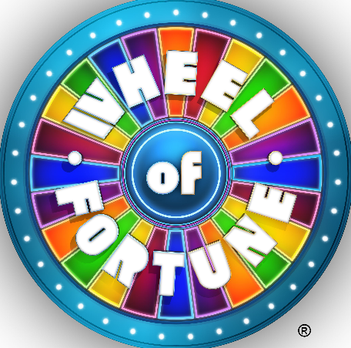
How to Spin

- Clap as the wheel spins and repeat, “Big prize. Big prize. Come on BIG PRIZE!!!”
- If the wheel stops on a number, write that number next to your name on the game sheet, then lookup that number in the List of Fortunes and complete whatever it says. Once you are able to complete the fortune, come back and mark the extra points down by your name. The person with the most points at the end of the week wins the grand prize!
- If the wheel also says, “Grab Bag!!,” then be sure to take a prize from the bag.
- If the wheel says, “BIG PRIZE!!!,” jump up and down and run around high fiving people. Say things like, “I NEVER THOUGHT THIS WOULD HAPPEN TO ME!!” Then see me for your prize.

