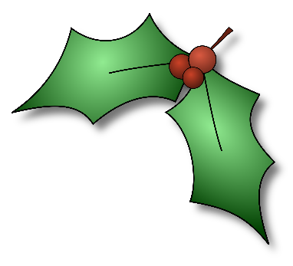
Holiday Village

This can be a fun way for everyone to contribute to an amazing party. Rather than simply having the standard party setup with food, chairs, and maybe a dance/mingling area, you set up tables and areas for different groups to set up themed areas. These areas can have different games, crafts, stories, and food. It’s all up to whatever that group wants to do. You can form the groups by grade level, or let them pick out their own groups. They’ll sign up for their theme beforehand, and have a few weeks to prepare. Plus, you can still include any other party activities you like.
Here’s how to pull it off:
1. In addition to any other emails you send regarding your party, send out this email ideally a few weeks before the event (at least one week at minimum) –
Hello All,
Have any of you ever heard of the old 19th century Romanian tradition of hosting a tiny village party??
Of course not, because I just made that part up. However, that doesn’t mean that it isn’t a good idea. The idea is that instead of just having the standard party setup of food and mingling, we mix it up with different areas and tables and we all get a chance to show off our own imaginations or traditions.
So for those who are interested to participate, what you do is join up with 4 or 5 of your friends (there is no strict limit), and pick out one of the themes I’ve listed below. My list is simply to get you inspired, so you’re also welcome to come up with a theme of your own if you so desire. Then email me your theme choice, and we’ll have an area with a table reserved for your group at the party.
What you do with your area is up to you. You can decorate it, provide a game or craft at your table, special food or treats, or whatever your team creativity comes up with. You can set it up so someone from your group is there to help man the station, or make it so it doesn’t need anyone. Then instead of just mingling in one big area, we’ll be able to walk around and see what everyone else came up with.
I would love for us to have enough participants to have 9 or 10 different tables at our party, or even more. How interesting and fun would that be!
So please consider having some fun and making a station. Pick your group and your theme as soon as you can so we can start to make any necessary arrangements.
Thanks, everyone!
Here are the theme ideas. Pick one of these, or come up with one of your own:
- Any country or city you might want, perhaps combined with their holiday or traditions. Examples: Christmas in Japan, or Hanukkah in Spain, winter in Pittsburg.
- Any of your own family’s special holiday traditions that you would like to share with us. Example: Cookies and treats our grannies taught us to make!
- Santa’s workshop
- Chocolate Factory
- Ornament craft station
- Donut decorating station
- Any movie themed station
- Any book themed station
- Gingerbread house station
- Snow station

