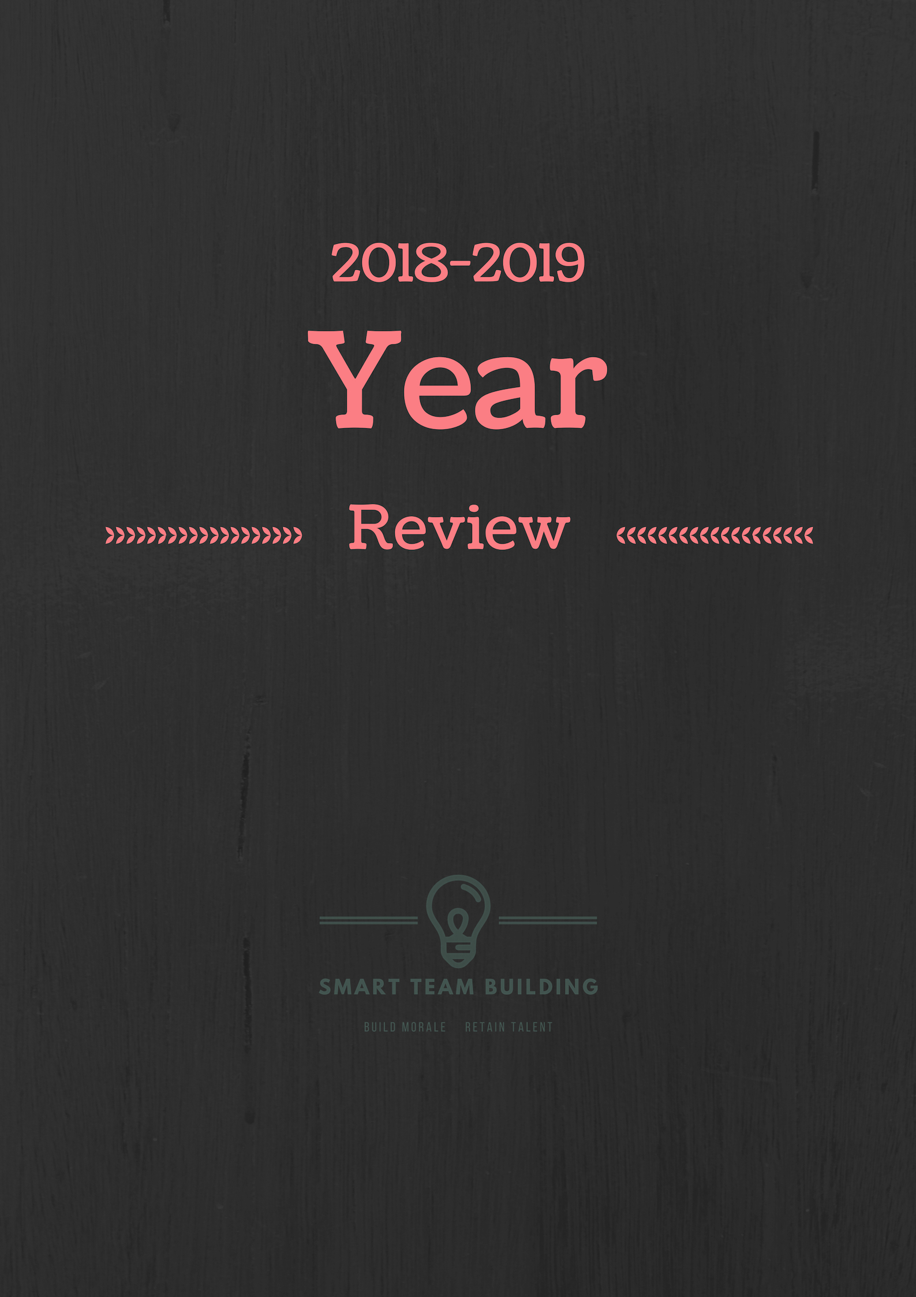
Survey and Presentation Instructions
Research has shown that periodic, somewhat sentimental reviews are an excellent way to build cohesion. This survey and presentation will bring your school together, allow them to have input on how the year went and what they liked and didn’t like, and leave them with a warm feeling going into the summer.
Because this is a review of your year, you will need to go through and customize it to reflect your school and experiences, but we’ve built all the structure and made it easy. All you need to do is edit the survey to input specifics for your school, send out the survey, and then use the answers to customize the presentation.
We recommend downloading the survey and presentation from the website and reading through both of them first to get an idea of everything, then go back and make your edits. This could also be a good opportunity to delegate this presentation to someone who would enjoy putting it together.
Here are the steps, and we’ll go over each in more detail on the next pages.
Step 1. Get your copy of the online survey and edit it to your liking. (We use Google Forms)
Step 2. Send out the survey.
Step 3. Once you’ve collected the responses, use them to fill in the presentation.
Step 4. Edit your presentation script and run through it once or twice.
Step 5. Have fun at your meeting!

Step 1. Obtain a copy of the Google Survey and then edit it to your liking (you might have already done 1-3):
1. This option uses Google Forms, which makes it easy for you to collect survey results. You will need to be signed in to a Google Account before you continue. If having a Google Account is a problem and you still would like to use a version of this option, please contact us.
2. After you are logged in to a Google Account, click this link: https://drive.google.com/open?id=1SlVVClvMf-UI916QWSu0P4hIS45YV3KeZmA0hJGLHD8
3. IMPORTANT: You must follow the steps below to make your own copy of the form to use it, otherwise, your survey responses will get mixed in with everyone else.
Click on the three dots at the top right and then click on Make a Copy. Rename the file and click OK. (If you are not logged in to a Google account, you won’t be able to Make a Copy)
You should now see that the Responses has reset to 0, as in the 2nd picture:
Original:
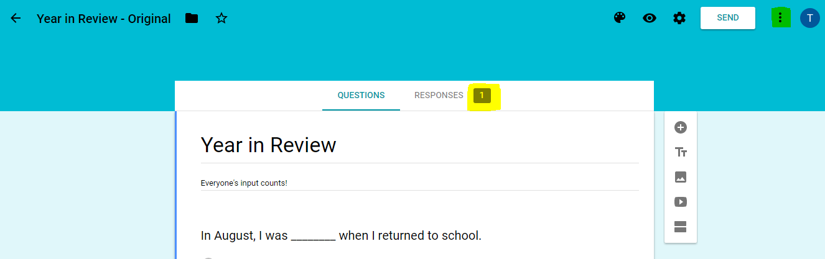

Once you have your copy, you’ll see the responses go to 0:
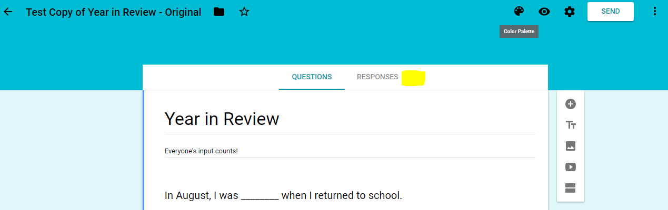
4. Once you have your own copy, you can scroll through the survey and edit it to your liking. You may delete questions, add questions, or anything you would like. Try to change things so they are specific to your school. In several instances, we used a generic, “Mr. Jones,” who you should change to a person at your school. We also put in some “caption this” photos that you can replace with photos of your own, perhaps a candid photo from this year.
You’ll use the answers from this survey to create your presentation, so it’s good to have some funny and some serious.

Step 2. Send out the survey.
1. Copy this text and paste it into an email that you will send out to all the staff:
Hello Everyone,
We’re putting together an end-of-year wrap up and want everyone’s input. If you would, please help us out with the following:
- Email us any pictures you have from this year, going all the way back to August. Help us out by only sending in the best so we don’t have hundreds to go through. Anything will do, but here are some we’re especially looking for:
- People hard at work (or maybe not so hard at work)
- Any of your favorite moments or events throughout the year
- Groups
- Candid’s
- Funny
- Serious
- Take a few moments and click on this link to take our survey: (insert link to survey here)

Thank you for helping out!

2. Once the survey is edited to your liking, click on Send up at the top. Then select the link icon next to “Send via.”
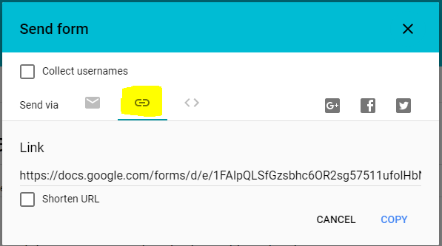
Copy the link and paste it into the email after #2.

3. Send the email out to all the staff.

Step 3. Once you’ve collected the responses, use them to fill in the presentation.
You can find all the responses to the survey by opening the file on your Google Account and clicking on Responses.
1. Make sure you’ve downloaded your own copy of the presentation from our website. This whole presentation is a quick parody on Saturday Night Live. You’ll read through the script as you go through the presentation. This presentation is best viewed and edited in PowerPoint, though it is compatible with several other programs. If you are experiencing trouble, contact tim@smartteambuilding.com .
2. The email you sent to the staff asked for people to send in their pictures, and you’ll use those to replace our pictures in the presentation. The easiest way to change a picture is to right click on it, click Change Picture, and then select the picture from your computer that you wish to change it to. Using this right click method will keep the size, formatting, and timing options. Do not simply change the pictures by deleting them and then clicking Insert Picture to add your own, because the new picture will not have the correct size, timing, or format.
3. The first four slides are meant to be super boring as a joke. Make any edits you see fit.
4. Slides 7 – 14 have lots of pictures you can change out with your own.
5. Slide 15 is the background slide while you give the monologue from the script.
6. Slides 16-19 are for the responses to celebrity look-alikes from the survey. You can replace the left-hand picture with a photo of the celebrity you find online, and the right-hand picture with a photo of the staff member. Tip: Try finding a photo of the celebrity first, then go around to the staff member and see if you can get them to pose like the celebrity and take their picture.
7. Slides 21-28 are to convey responses from the survey. You do not need to use all of them and you’ll probably want to edit these the most. If you put in different questions in your survey and got some good responses, this is a good place to put them.
8. Slide 29 is for a Special Report. This is where we recommend you pause to discuss all of the more serious questions and responses from the survey, such as how we can improve, what did you like best, etc… You can either have a guest come up and give this report, of do it yourself.
9. Slide 30 is just for fun if you used the ridiculous survey question, “Which is best.”
10. Slides 31 – 36 are for awards. We asked the question in the survey who they would give an award to, and here you can put some of the top responses and replace the pictures.
11. Slides 38-41 are where you can put more pictures from the year.

Step 4. Edit the script and make sure it matches your presentation.
This is a Saturday Night Live parody, and it’s easy for you to customize it. Read through it, delete the comments and slides you don’t want, and keep the rest.
Section 1 – Opening (The boring meeting)
“If everyone would take a seat, we’ll get started…
Now you can just follow along and read the first three slides like a normal presentation. You’ll need to hit the Next arrow to advance them. If you really want to get into it, read everything on the slide in as boring a manner as possible. Really make them believe they are in for a long and awful meeting.
After the team building exercise, you can click next and everyone can help say, “Live! From New York… It’s Saturday Night!” Or you can change the slide to say something like, “Live, From Northside Elementary… It’s Friday Afternoon!!!”
Now the opening theme will play and show and scroll through some pictures. When it stops, you’ll hear some clapping and see the background change. At this point, you can go stand in front of everyone and read through your monologue:
Monologue
Thank you. Thank you. Thank you very much. Yes. This is, uh, this is fantastic. Yes. I'm just so excited to be back here at (insert school name and location, example– “Northside Elementary cafeteria.”). Uh, as you know, I’ve worked here for ____ years, and uh, this is my first time ever hosting this show. Which, of course, is a thrill. I mean, to actually get to host. I mean.. it's unbelievable. And, uh.. I have to be honest, I thought I was gonna be a little nervous. But I'm not - thanks to you guys. I feel relaxed, I feel great.
I thought I would start out by sharing a few things with you I learned recently.
Did you know that the word, “whompist,” could have several different meanings as it relates to this school? Yeah, yeah. Here are some of the suggestions I’ve heard: (read some of the funny answers from the survey)
Oh, and let me read some of these submissions to you: “If I found a note that read, "Mr. Jones just found a P.P.A.," I would assume that P.P.A. stands for…” (read some of the funny answers from the survey)
Ok. One more. “Next year, we should require a class and permit before anyone is allowed to...” (read some of the funny answers from the survery)
Hey, we’ve got a great show for you. The Red Hot Chili Peppers are here… or at least we scheduled them, though I’m not sure if they’re actually going to show… And we’ve got a lot more to share. So stick around, we’ll be right back.

Click Next Slide and the presentation will play some commercial music and show some pictures for about a minute. You can take this time to do a scene change and bring out a table and chairs that will serve as your news anchor desk for the Weekend Update. You can do this by yourself or have a cohost and take turns reading through the slides.
If you’ve edited the slides to add or delete any, make sure you’ve gone through this script to make sure the slides and the script match up.
Once the music stops, you can start:
2017-2018 Year In Review Update (Weekend Update)
Good afternoon, I’m ________, and here are our top stories:
SLIDE: The funniest thing I saw a student do this year was ________.
SLIDE: The one game I hope never to see our students playing in the lunchroom is ________.
SLIDE: (Go through the funny photo and captions.)
SLIDE: Imagine Abraham Lincoln visited our school, what would you like to say to him?
SLIDE: Are you a time-traveler?
SLIDE: The best dressed person at school is _____.
SLIDE: When I saw ____ this year, all I could do was laugh and shake my head.
And now, here with a special report and the results from some of your suggestions from the survey, is _________. Invite an assistant or person of your choosing to join you behind the desk and go over some of the more important questions from the survey. We’ve done our best to open things up and make them light, so you should be able to have a good interaction and even open it up for discussion. Topics you could include:
- Some of the things we did right and that we should repeat next year: (For each of these answers, use some of your favorite suggestions from the survey. Typically, about 4 or 5 answers should do. Usually, you’ll have gotten several good answers, and even some funny ones. )
- Some of the things we got wrong:
- Some things that could make your jobs easier and more successful:
Ok, thank you _______.
SLIDE: This just in! Which is best?
And now, to finish up, we have some awards to hand out as suggested by your peers. If I call your name, please stand up so we can recognize you.
After the presentation, you might have other items to go over with your meeting, or you can thank everyone for a great year and tell them to have a wonderful summer!

